AP Biology Unit 1 Guided Notes Packet
  - AP Biology Unit 1
Name ______________________________________________________
Class ______________________________________________________
Date ______________________________________________________
Use this compact packet with the online lessons. Record the cloze notes and complete each matching, labeling, or ordering task when it appears in the lesson.
Lesson | Topic | Learning goals | Science practice focus
0C | Chemistry Review  Optional prerequisite support | Describe atoms, elements, and compounds used to build biological molecules.; Distinguish covalent bonds, polarity, ions, and hydrogen bonds.; Track atoms and energy when bonds change.
01 | Water's Unusual Power  Topic 1.1 | Represent the polarity of water and hydrogen bonding between molecules.; Explain cohesion, adhesion, high specific heat, and evaporative cooling from molecular structure.; Use data or a biological observation as evidence for a structure-property explanation. | 2.A: Describe the important features of a visual model of water and hydrogen bonding.
02 | From Elements to Polymers  Topics 1.2-1.3 | Identify the major elements used to build biological macromolecules.; Model dehydration synthesis and hydrolysis.; Infer how monomer number, type, arrangement, and sequence contribute to molecular diversity. | 2.A: Describe how a molecular model represents monomers, polymers, and reactions.
03 | Carbohydrates & Lipids  Topics 1.4-1.5 | Connect monosaccharide structure and glycosidic bonds to carbohydrate functions.; Compare triglycerides, phospholipids, and steroids.; Predict how saturation and amphipathic structure affect molecular behavior. | 1.A and 6.E: Describe structure-function relationships and predict how a structural change affects function.
04A | Nucleic Acids  Topic 1.6 | Identify the three parts of a nucleotide and explain how sequence stores information.; Compare DNA and RNA using sugar, base, and typical strand organization.; Interpret 5′ and 3′ ends, antiparallel orientation, and complementary base pairing.
04B | Proteins  Topic 1.7 | Identify amino-acid parts and peptide bonds.; Describe primary, secondary, tertiary, and quaternary protein structure.; Predict how sequence or environmental changes may affect protein function.
05 | Macromolecule Evidence Lab  Topics 1.1-1.7 synthesis | Select tests that detect reducing sugars, starch, protein, or lipids.; Interpret positive and negative controls before unknown results.; Defend a sample identification with multiple lines of evidence. | 6.B and 6.C: Support a claim with evidence and connect the evidence to biological reasoning.
0A | Scientific Method: Design & Controls  AP Biology Science Practices | Write a testable hypothesis and a directional prediction.; Identify independent, dependent, and controlled variables.; Choose positive, negative, and same-procedure controls and say what each rules out. | 3.C and 4.B: Identify variables and appropriate controls, then describe patterns and relationships in data.
0B | Scientific Method: Data & Conclusions  AP Biology Science Practices | Use replication, sample size, and randomization to support a claim.; Choose a data display and quantify uncertainty.; Write a conclusion that distinguishes association from causation.

Optional 0C Chemistry Review

Atoms and Elements

Visual model task
Match each numbered observation to its lettered explanation, then record the relationship.
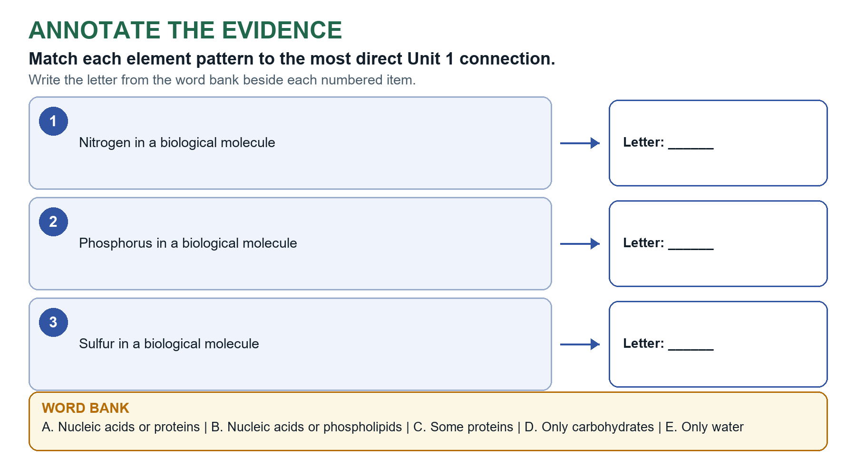
Model summary ___________ are environmental building blocks. Link each one to the macromolecules that require it.
- Matter, elements, and compounds: _________ has mass and occupies space. An element has one atom type; a compound has two or more elements chemically combined in a fixed ratio.
- Atomic structure: Protons and neutrons are in the nucleus; electrons are in the ___________ cloud. Atomic number = protons; isotopes differ in neutron number; valence electrons matter in bonding.

Chemical Bonds and Polarity
- Electronegativity and polarity: Electronegativity is _____________ for shared electrons. Nonpolar covalent bonds share relatively equally; polar covalent bonds share unequally and create partial charges.
- Ionic and hydrogen bonds: Ionic bonds attract ___________ ions. Hydrogen bonds attract a partial-positive H to an electronegative atom on a nearby molecule.
- Water interactions: Polar molecules and ions are often ______________; nonpolar molecules or regions are hydrophobic.

Chemical Reactions and Energy
- Matter and energy: Reactions conserve atoms. Breaking bonds requires _________ input; forming bonds releases energy. Overall energy release depends on both changes.

Optional AP style explanation
- Complete this only when assigned. Use a claim, specific evidence, and the biological relationship that connects them.
________________________________________________________________________________________

What You Should Now Be Able to Explain
- How atoms, elements, and compounds differ: ________________________________________________
- How a polar covalent bond differs from an ionic or hydrogen bond: ________________________________________________
- Why polarity changes interactions with water: ________________________________________________
- Why reactions conserve atoms even when bonds change: ________________________________________________
Key takeaway: Atoms are conserved as reactions rearrange bonds; ___________ and intermolecular attractions help explain Unit 1 structure-function relationships.

Lesson 01 Water's Unusual Power

Water’s Molecular Structure
- Cohesion vs. adhesion: Cohesion is hydrogen bonding between water molecules. Adhesion is hydrogen bonding between water and a different molecule or polar surface, such as an _____________ or a xylem wall.

Cohesion, Adhesion, and Surface Tension

Visual model task
Write the letter from the diagram's lettered label bank beside each numbered target.
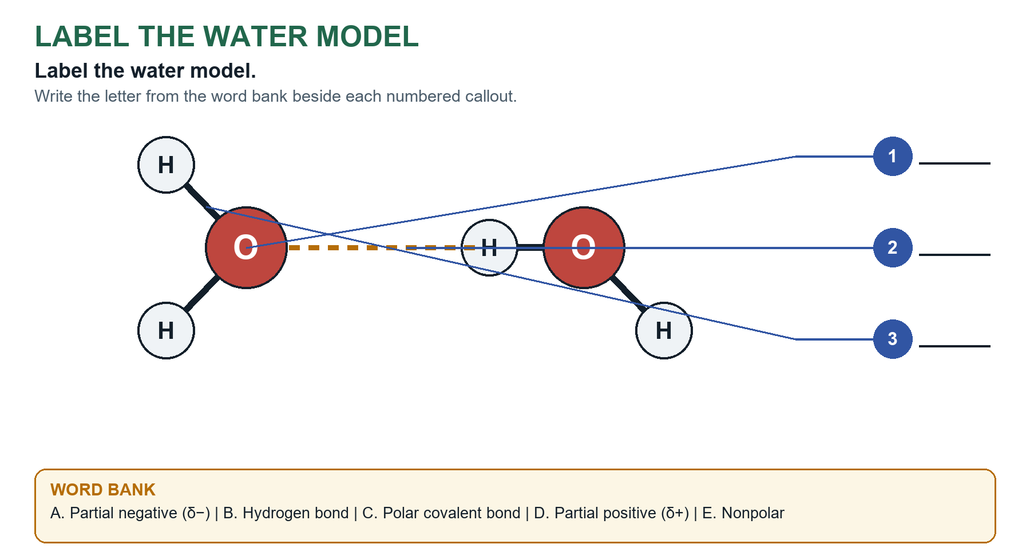
Model summary A polar covalent bond holds O and H together within a molecule; a weaker ________________ attracts neighboring molecules.
- Water polarity: _________ pulls shared electrons more strongly, producing δ− near oxygen and δ+ near hydrogen.
- Hydrogen bond model: The δ+ hydrogen of one molecule is attracted to the δ− _________ of another molecule.

Water and Temperature Regulation
- Specific heat capacity: The energy required to raise a substance's temperature. Hydrogen bonding gives water high ________________ capacity and resistance to rapid temperature change.
- Heat of vaporization and cooling: The _________ required to convert liquid to gas. During evaporation, higher-energy water molecules leave, lowering the remaining liquid's average kinetic energy and temperature.
- Cohesion and adhesion in transpiration: ___________ transmits tension through the column. Adhesion supports water against xylem walls.

Apply Water’s Properties
- Surface tension: Hydrogen __________ among surface molecules produces a cohesive surface.
- Ice floats: In ice, hydrogen bonds hold water molecules in a more open pattern, so solid water is less dense than liquid water and floats. Ice that forms on the surface leaves liquid water below, so aquatic organisms can survive in freezing ___________.
- Solvent and capillary action: Liquid water dissolves many ions and polar molecules, which helps organisms get nutrients from the environment. Water is a very good solvent, but it is not a universal solvent. Adhesion and ___________ also pull water up narrow tubes (capillary action), which plants use to take up soil water.

AP-style transfer
- One-sentence synthesis: Water's ___________ enables hydrogen bonding, which produces properties that support transport and temperature stability.
Important Identify names the property.

Optional AP style explanation
- Complete this only when assigned. Use a claim, specific evidence, and the biological relationship that connects them.
________________________________________________________________________________________

What You Should Now Be Able to Explain
- Why water molecules form hydrogen bonds: ________________________________________________
- Why hydrogen bonding produces cohesion and surface tension: ________________________________________________
- How high specific heat and high heat of vaporization support thermoregulation: ________________________________________________
- How cohesion and adhesion contribute to transpiration: ________________________________________________
Key takeaway: Water ___________ to hydrogen bonding to emergent properties to transport and temperature stability.

Lesson 02 From Elements to Polymers

Elements of Life
- Most prevalent elements: Carbon, hydrogen, and _________ are most prevalent in biological macromolecules. Carbon forms their carbon skeletons.
- Energy and matter: Living systems need a constant input of energy and must exchange _________ with the environment. Carbon skeletons (chains, rings, and branches) can store chemical energy and form cell structures.

Monomers and Polymers
- Special elemental roles: Nitrogen: amino acids and nucleic acids. Phosphorus: nucleic acids and phospholipids. Sulfur: certain amino acids and ____________ bridges in proteins.
- Matter source: Organisms _________ atoms from the environment and rearrange them into new molecules.
- Monomer and polymer pairs: Specific monomers build specific polymers: monosaccharides build polysaccharides, amino acids build proteins, and nucleotides build nucleic acids. A __________ is a subunit, not a single atom.

Dehydration Synthesis

Visual model task
Write the letter of each model or event in the correct numbered position.
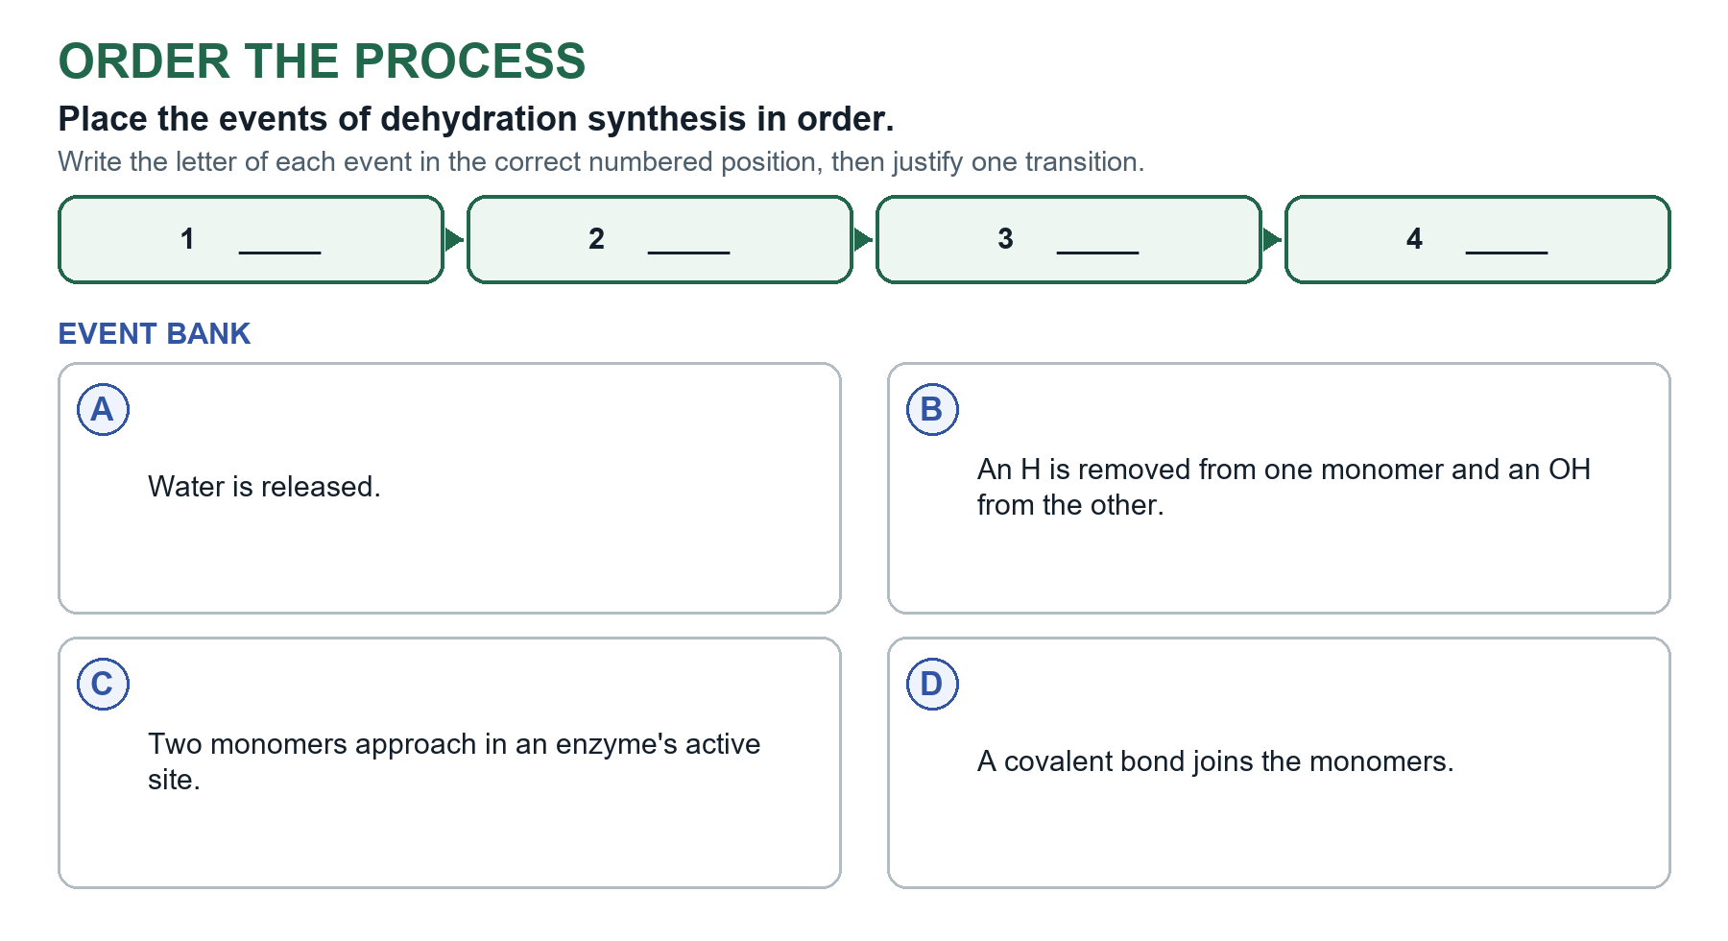
Model summary The model _____________ atom conservation: H and OH become water as the new bond forms.
- Dehydration synthesis: H and OH are removed as water while a covalent bond forms between ___________.
- Polymerization: Repeated covalent joining of monomers builds a __________.

Hydrolysis
- Hydrolysis: Water is added across a ___________ bond. H and OH join separate products as the bond breaks.

Apply Atom Conservation
- Sequence and function: The identity, number, and order of monomers influence __________________ shape and biological function.
- Effect of a sequence change: A ___________ change may alter folding, binding, catalysis, or stored information; the effect depends on its location.

Optional AP style explanation
- Complete this only when assigned. Use a claim, specific evidence, and the biological relationship that connects them.
________________________________________________________________________________________

What You Should Now Be Able to Explain
- How C, H, O, N, P, and S contribute to biological molecules: ________________________________________________
- How dehydration synthesis conserves atoms while forming a covalent bond: ________________________________________________
- How hydrolysis uses water to break a covalent bond: ________________________________________________
- Why monomer sequence can change polymer function: ________________________________________________
Key takeaway: Organisms rearrange environmental atoms; dehydration builds and _____________ breaks biological molecules.

Lesson 03 Carbohydrates & Lipids

Carbohydrate Structure
- Carbohydrate organization: Monosaccharides join by ___________ bonds (called glycosidic bonds) into linear or branched polysaccharides.

Carbohydrate Functions
- Carbohydrate functions: Glucose provides _________ for cells; starch stores energy in plants; glycogen stores energy in animals; cellulose supports plant cell walls.
- Direction of subunits matters: Glucose can differ in the direction of one OH group. Joined one way it makes starch, which stores _________ in plants. Joined the other way it makes cellulose, which supports plant cell walls. Some starch is linear, so judge by the picture.
- Starch, glycogen, and cellulose: Starch (plants) and glycogen (animals) are similar branched polymers that store _________. Cellulose is linear, and hydrogen bonds between side-by-side strands cluster them into strong fibers.
Important Describe the shape in a picture, linear or branched, and then relate it to the function.

Lipid Structure and Properties

Visual model task
Write the letter from the diagram's lettered label bank beside each numbered target.
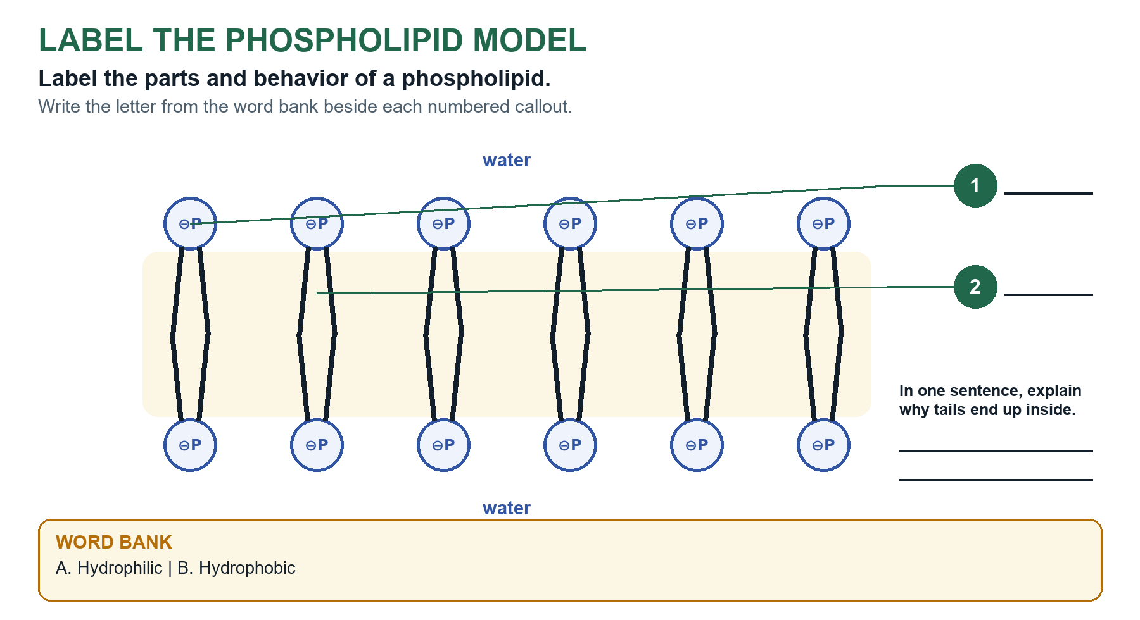
Model summary Amphipathic molecules have both ______________ and hydrophobic regions.
- General lipid property: Lipids are typically nonpolar and ______________, and are not true polymers because they do not all have repeating monomer subunits.
- Saturation comparison: Saturated tails have only C-C single bonds. Unsaturated tails have ______________ kinks.

Saturated and Unsaturated Fatty Acids
- Unsaturation and state: More double bonds to more kinks to less __________ to more liquid at room temperature.
- Hydrogenation: Fewer double bonds to more saturation and packing to __________ solidity.

Types and Functions of Lipids
- Lipid functions: Triglycerides store _________ and insulate. Steroids include hormones and cholesterol. Cholesterol contributes to stability and fluidity in animal membranes.
- Amphipathic phospholipids: A _______________ has a polar hydrophilic head and nonpolar hydrophobic tails. In water, heads face water and tails point inward to form a bilayer.

Phospholipids and Cell Membranes

Optional AP style explanation
- Complete this only when assigned. Use a claim, specific evidence, and the biological relationship that connects them.
________________________________________________________________________________________

What You Should Now Be Able to Explain
- How linear and branched polysaccharides support different functions: ________________________________________________
- Why lipids are generally hydrophobic: ________________________________________________
- How C=C double bonds change fatty-acid packing and fluidity: ________________________________________________
- Why phospholipids form bilayers in water: ________________________________________________
Key takeaway: ____________ assembly changes shape, packing, interactions with water, and biological function.

Lesson 04A Nucleic Acids

Nucleotide Structure

Visual model task
Write the letter from the diagram's lettered label bank beside each numbered target.
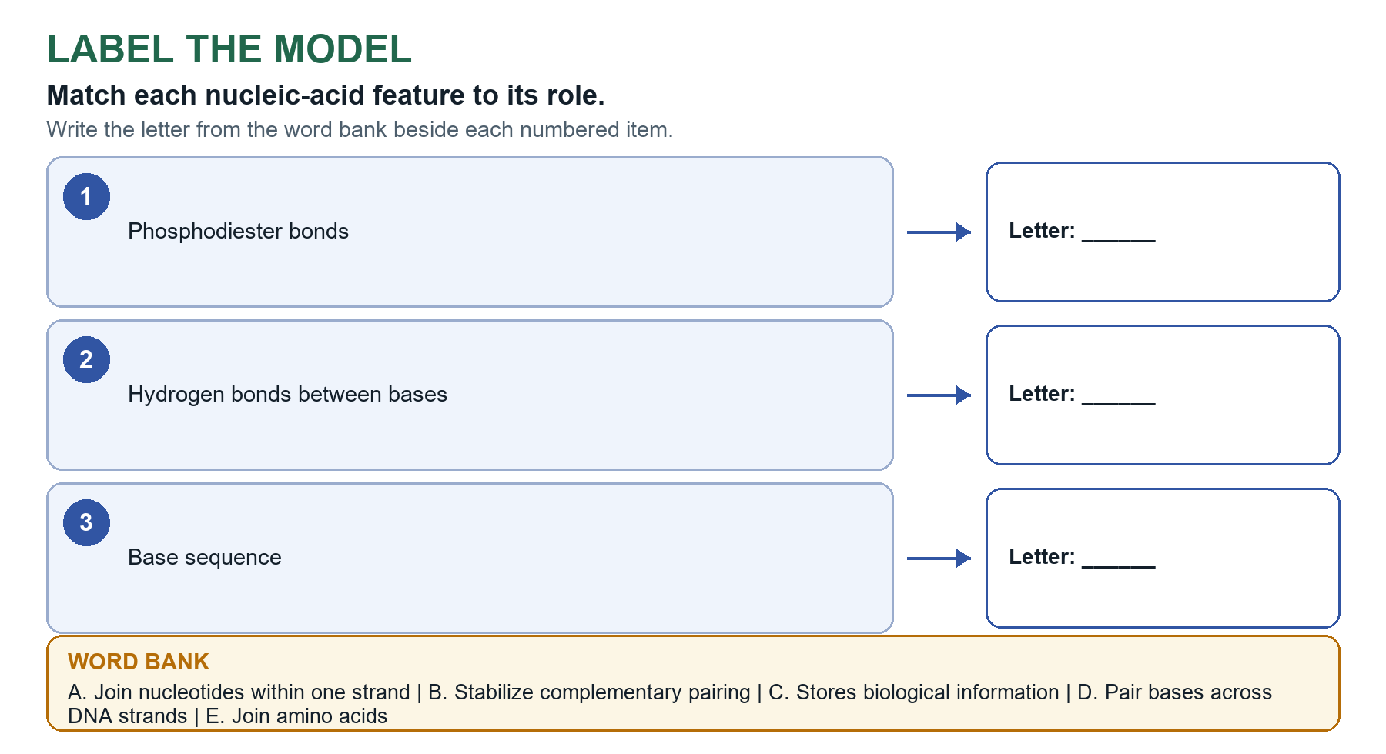
Model summary Separate the covalent backbone from ___________ bonding between bases.
- Nucleotide: Five-carbon sugar + phosphate + nitrogenous base. _____________ sequence stores biological information.

DNA and RNA
- DNA vs. RNA: DNA: deoxyribose, T, usually double stranded, and stores genetic information. RNA: ribose, U, usually single stranded, and _______________ in using genetic information.

Nucleic Acid Structure and Directionality
- Sugar-phosphate backbone: Covalent bonds (phosphodiester bonds) join the phosphate of one _____________ to the sugar of the next, forming the sugar-phosphate backbone of each strand.
- Directionality: 5′ end has phosphate. 3′ end has a free ___________. New nucleotides are added to the 3′ end.

Complementary Base Pairing
- Antiparallel pairing: DNA strands run oppositely. A-T and C-G pair by ___________ bonds; RNA can use A-U.
- Hydrogen bonds and stability: A-T pairs have two hydrogen bonds and G-C pairs have three. A DNA __________ with more G-C pairs has more hydrogen bonds, is more stable, and needs more heat to separate.
Important When a prediction names two things, address both.

Optional AP style explanation
- Complete this only when assigned. Use a claim, specific evidence, and the biological relationship that connects them.
________________________________________________________________________________________

What You Should Now Be Able to Explain
- The three parts of a nucleotide: ________________________________________________
- How DNA and RNA differ: ________________________________________________
- How 5′ and 3′ ends establish directionality: ________________________________________________
- Why complementary pairing and antiparallel orientation matter in DNA: ________________________________________________
Key takeaway: _____________ sequence stores genetic information; complementary base pairing and antiparallel strands support DNA structure and function.

Lesson 04B Proteins

Amino Acid Structure
- Amino acid: Central carbon bonded to H, amino group, carboxyl group, and ___________ R group. R groups may be nonpolar, polar, or charged.

Peptide Bonds
- Peptide bond: Covalent bond between the carboxyl group of one _____________ and the amino group of the next. A polypeptide is a chain of amino acids joined by peptide bonds.
- Amino and carboxyl ends: An _____________ has an amino terminus (amine group) and a carboxyl terminus. A growing polypeptide gains new amino acids at its carboxyl end.

Four Levels of Protein Structure
- Protein levels: Primary = sequence; ____________ = alpha helices and beta sheets stabilized by backbone hydrogen bonds; tertiary = one chain's 3-D shape; quaternary = two or more subunits.

R-Group Interactions and Folding
- R-group interactions: ______________ interactions, hydrogen bonds, ionic interactions, and cysteine disulfide bridges support folding.
- Folding in water: In water, nonpolar (______________) R groups fold toward the core and polar R groups face the water. Many proteins work at the tertiary level, and hemoglobin needs quaternary structure.

Protein Structure and Function

Visual model task
Write the letter of each model or event in the correct numbered position.
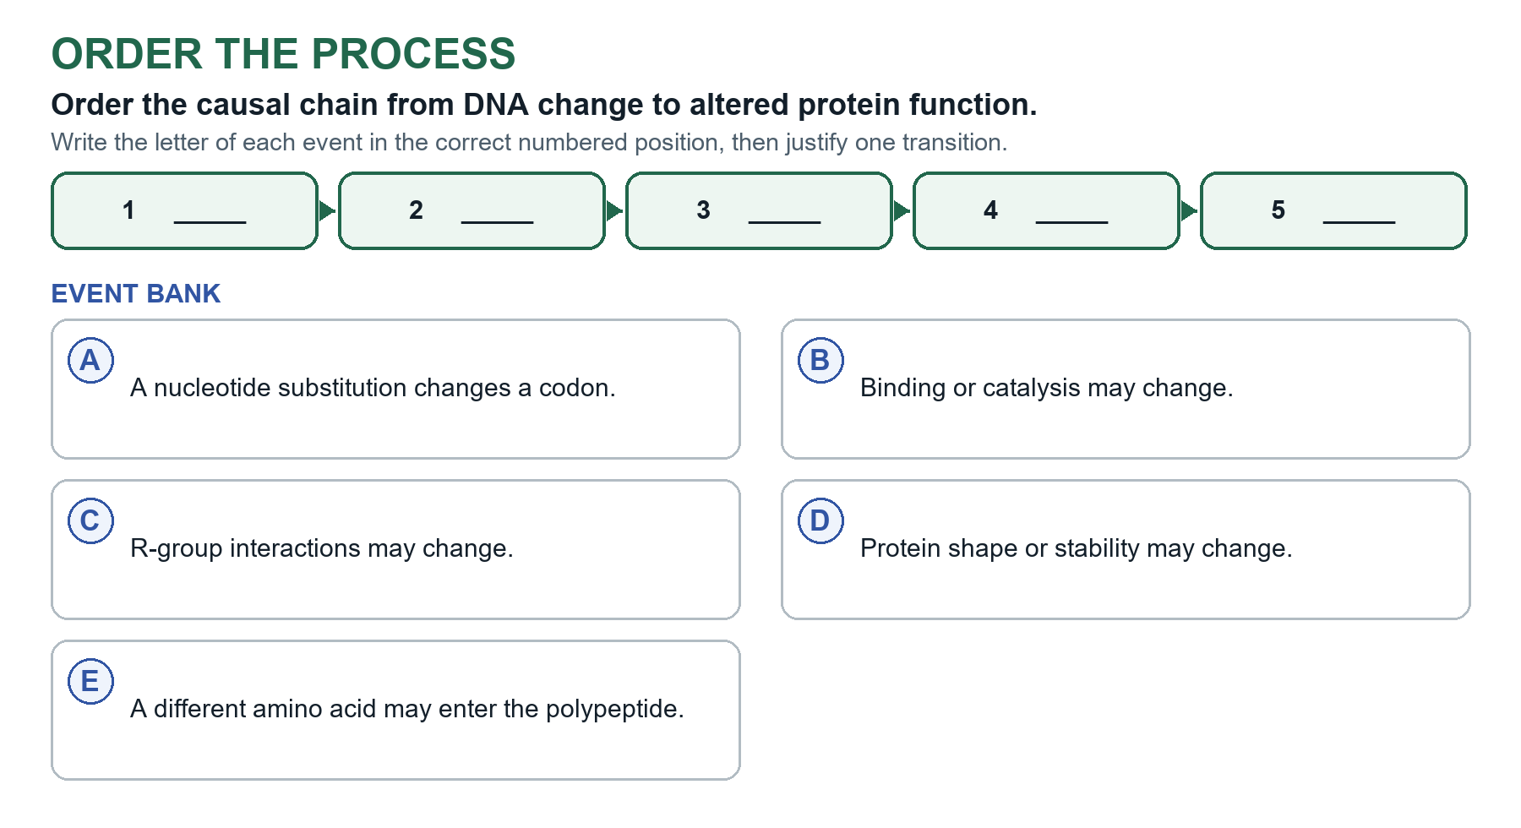
Model summary The strongest explanation supplies each mechanistic link and avoids assuming that every ___________ has an effect.
- Sequence-to-function chain: Sequence to R-group interactions to folding/shape to function. A substitution's effect depends on location and chemical _______________.
Important When a question asks for two predictions, such as fit with a signal molecule and function, address both.

Denaturation
- Denaturation: ______________, pH, or solutes can disrupt shape and function without necessarily breaking peptide bonds.

Optional AP style explanation
- Complete this only when assigned. Use a claim, specific evidence, and the biological relationship that connects them.
________________________________________________________________________________________

What You Should Now Be Able to Explain
- The common structure of an amino acid: ________________________________________________
- How peptide bonds create a polypeptide: ________________________________________________
- How the four levels of protein structure differ: ________________________________________________
- Why sequence or environmental changes may affect protein function: ________________________________________________
Key takeaway: ______________________ to R-group interactions to folding and three-dimensional shape to biological function.

Lesson 05 Macromolecule Evidence Lab

Experimental Controls
- Positive and negative controls: A ___________________ contains the target and confirms detection. A negative control lacks the target and establishes the expected negative result.

Chemical Tests for Macromolecules
- Benedict's test: After __________, a green-to-brick-red change detects reducing sugar.
- Iodine test: A blue-black change detects _________.
- Biuret test: A violet change detects peptide bonds/__________.
- Sudan IV test: A separated stained layer supports the ___________ of lipid.

Using Evidence to Identify an Unknown

Visual model task
Match each numbered observation to its lettered explanation, then record the relationship.
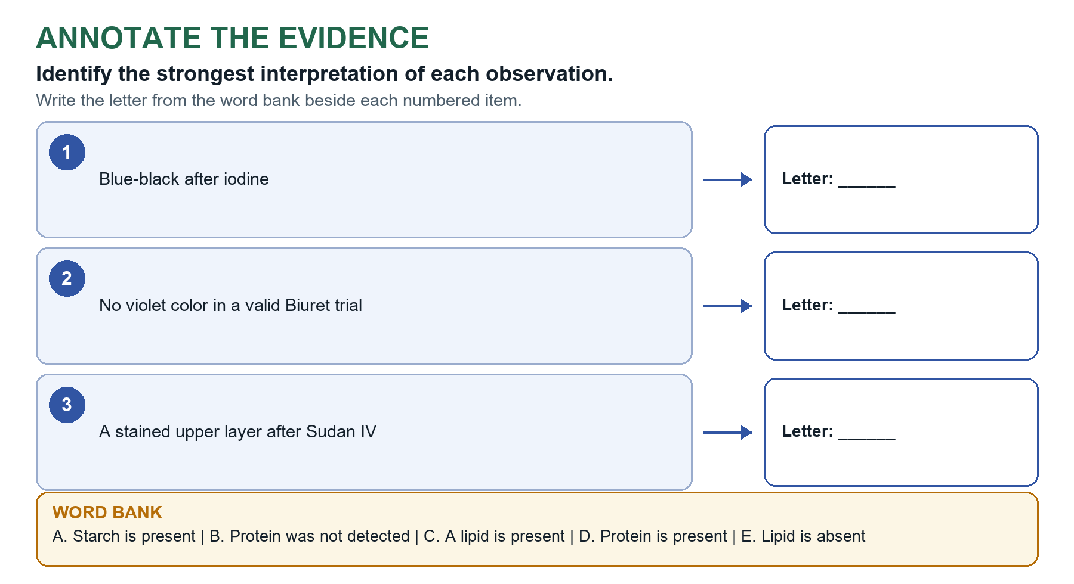
Model summary State exactly what the test detects; do not make a broader claim than the ___________ supports.
- Evidence rule: Use a diagnostic ___________ and relevant negative result. Claim only what the test detects.
- CER frame: Identify the __________, cite results, and explain how the results support or rule out alternatives.

Optional AP style explanation
- Complete this only when assigned. Use a claim, specific evidence, and the biological relationship that connects them.
________________________________________________________________________________________

What You Should Now Be Able to Explain
- Why positive and negative controls are needed: ________________________________________________
- What each indicator test detects: ________________________________________________
- How a negative result can rule out an alternative: ________________________________________________
- How to write a claim-evidence-reasoning identification: ________________________________________________
Key takeaway: A defensible identification combines valid controls, _____________ results, and a claim limited to what the tests show.

Optional 0A Scientific Method: Design & Controls

Scientific Investigations
- Observation: Information collected about a _____________.
- Hypothesis: A tentative, testable, and falsifiable explanation-not a question or a _____________ fact.
- Prediction: The measurable result expected if the _____________ is supported, often written as an if-then statement.
- Null hypothesis: The treatment or variables have no effect or ______________ beyond chance.
- Evidence rule: Evidence may support or fail to support a _____________; one experiment does not prove it true.
Important Do not say that one test proves a hypothesis or that an observed association proves causation.

Variables define the comparison

Visual model task
Write the letter from the diagram's lettered label bank beside each numbered target.
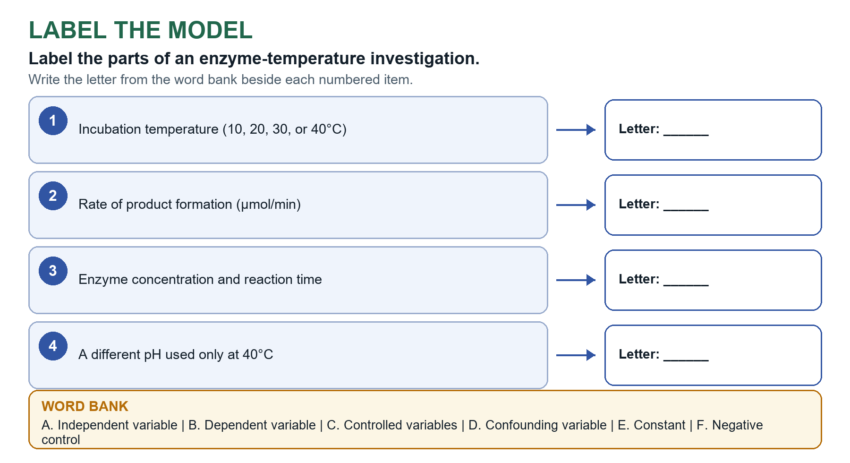
Model summary A fair test changes the _______________________ while measuring the dependent variable and holding other plausible causes constant.
- Independent and dependent variables: The _______________________ is the factor the investigator deliberately changes. The dependent variable is the measured response.
- Controlled variables: Conditions intentionally kept the same across groups so the comparison isolates the _______________________.
- Experimental and control groups: The experimental group receives the treatment; the __________ group provides the comparison.
- Confounding variable: A factor that changes along with the _______________________ and creates another possible explanation for the result.
Important Do not say one test proves a hypothesis or turns a link into a cause.

Controls make results interpretable
- Negative control: An expected baseline or negative result that reveals background or contamination. A same-procedure __________ receives the solvent or carrier without the active treatment.
- Positive control: A condition known to __________ the response, showing that the test system itself is working.
Important Do not claim a treatment effect if the controls make the result hard to interpret.

Optional AP style explanation
- Complete this only when assigned. Use a claim, specific evidence, and the biological relationship that connects them.
________________________________________________________________________________________

What You Should Now Be Able to Explain
- How a hypothesis differs from a prediction: ________________________________________________
- How independent and dependent variables define a test: ________________________________________________
- Why positive, negative, and same-procedure controls are useful: ________________________________________________
Key takeaway: A fair test changes one planned factor, measures a response, and uses controls to make the comparison ________________.

Optional 0B Scientific Method: Data & Conclusions

Design for reliability and reduced bias

Visual model task
Write the letter of each model or event in the correct numbered position.
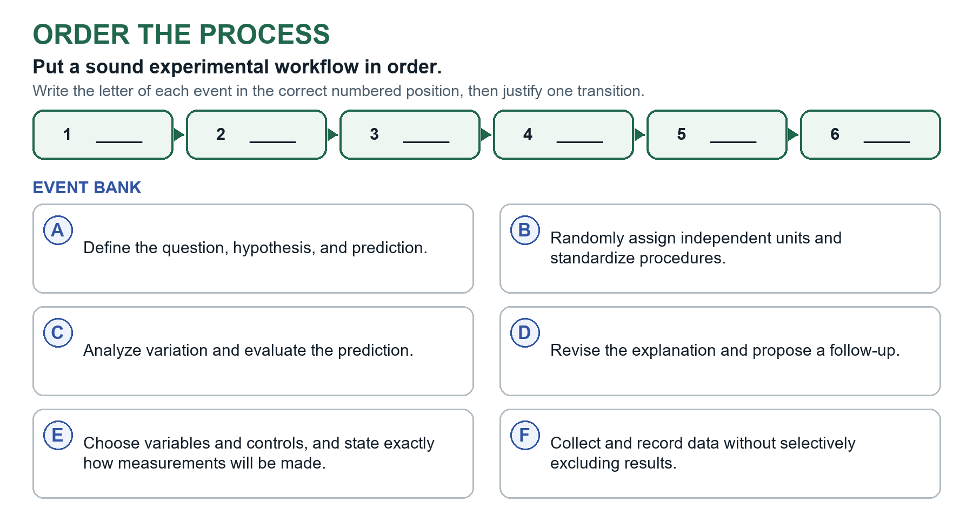
Model summary ___________ precedes data collection; interpretation follows analysis and leads to revision or a new test.
- Replicates: A biological replicate is an independent organism, culture, or experimental unit. A technical replicate is a repeated ______________ of the same unit.
- Sample size: More ______________ samples better represent biological variation and improve the estimate.
- Random assignment and bias: Random assignment reduces systematic differences among groups; standardized methods and blinding reduce ______________ and observer bias.
Important Do not say one test proves a hypothesis or turns a link into a cause.

Represent data and quantify uncertainty
- Graph axes: Place the _______________________ on the x-axis and the dependent variable on the y-axis.
- Graph choice: Use bars for groups, lines for __________ change, and scatterplots for two measured quantities.
- Rate: _________ in the measured quantity divided by change in time.
- Mean: The arithmetic average of a set of _________.
- Standard deviation: Describes the spread of individual _________ around the mean.
- Standard error and confidence intervals: Standard error estimates ______________ in a sample mean. A confidence interval describes uncertainty in an estimated population parameter.
- Error bars: Represent a specified measure of variation or ______________; identify their meaning before interpreting them.

Argue from evidence without overclaiming
- Claim-evidence-reasoning: State the conclusion, cite specific ___________, and explain the biological reasoning that links them.
- Causation and limitations: A controlled test can support causation; an observational ______________ cannot. Name a design limit or alternative explanation and propose a focused next test.

Optional AP style explanation
- Complete this only when assigned. Use a claim, specific evidence, and the biological relationship that connects them.
________________________________________________________________________________________

What You Should Now Be Able to Explain
- Why biological replicates differ from repeated measurements: ________________________________________________
- How graph choice and error bars affect interpretation: ________________________________________________
- Why association does not by itself establish causation: ________________________________________________
- How claim, evidence, and reasoning work together: ________________________________________________
Key takeaway: Strong conclusions match the design and ___________ without claiming more than the data support.

