AP Biology Unit 1 Outline Notes
  - AP Biology Unit 1
These completed notes follow the online lessons in order. Each lesson states the central biological model, explains the required relationships, shows a labeled diagram, and includes worked examples. Use the notes to preview a lesson, check concise guided notes, or review for an assessment.
Lesson | Topic | Labeled model
0C | Chemistry Review | Match each element pattern to the most direct Unit 1 connection.
01 | Water's Unusual Power | Rotate a water molecule to form a hydrogen bond
02 | From Elements to Polymers | Build and break a polymer
03 | Carbohydrates & Lipids | Structure changes packing and function
04A | Nucleic Acids | Match each nucleic-acid feature to its role.
04B | Proteins | Order the causal chain from DNA change to altered protein function.
05 | Macromolecule Evidence Lab | Use controls to interpret indicator tests
0A | Scientific Method: Design & Controls | Build a fair comparison
0B | Scientific Method: Data & Conclusions | Put a sound experimental workflow in order.

Optional 0C Chemistry Review
  - Optional prerequisite support

Central idea
Use this optional refresher to connect atomic structure, charge patterns, and chemical reactions to the Unit 1 models.

Learning targets
- Describe atoms, elements, and compounds used to build biological molecules.
- Distinguish covalent bonds, polarity, ions, and hydrogen bonds.
- Track atoms and energy when bonds change.

Labeled lesson model
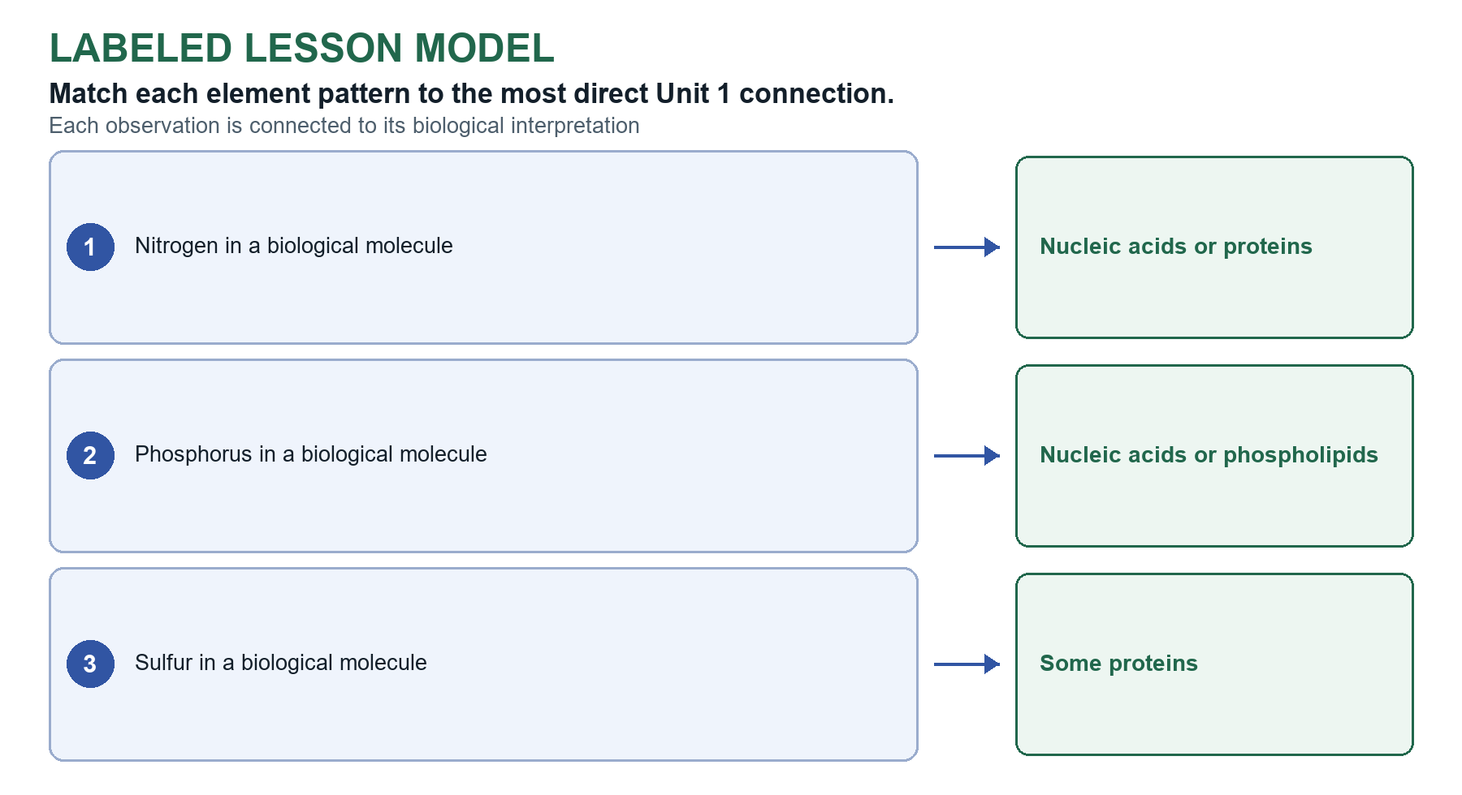
Figure 1 Completed model for Chemistry Review

Atoms and Elements
Matter has mass and occupies space.

Key points
- Matter, elements, and compounds Matter has mass and occupies space. An element has one atom type; a compound has two or more elements chemically combined in a fixed ratio.
- Atomic structure Protons and neutrons are in the nucleus; electrons are in the electron cloud. Atomic number = protons; isotopes differ in neutron number; valence electrons matter in bonding.
- Particles Protons (+) and neutrons (0) are in the nucleus. Electrons (−) occupy the electron cloud.
- Atomic identity Atomic number = protons. Isotopes are the same element with different neutron numbers. Valence electrons help determine bonding.

Worked example
Question Match each element pattern to the most direct Unit 1 connection.
- Answer Nitrogen in a biological molecule: Nucleic acids or proteins
- Answer Phosphorus in a biological molecule: Nucleic acids or phospholipids
- Answer Sulfur in a biological molecule: Some proteins
Why it works Elements are environmental building blocks. Link each one to the macromolecules that require it.

Chemical Bonds and Polarity
Electronegativity is an atom’s ability to attract shared electrons.

Key points
- Electronegativity and polarity Electronegativity is attraction for shared electrons. Nonpolar covalent bonds share relatively equally; polar covalent bonds share unequally and create partial charges.
- Ionic and hydrogen bonds Ionic bonds attract opposite ions. Hydrogen bonds attract a partial-positive H to an electronegative atom on a nearby molecule.
- Water interactions Polar molecules and ions are often hydrophilic; nonpolar molecules or regions are hydrophobic.
- Polarity and water Polar molecules have an unequal charge distribution. Ions and many polar molecules are hydrophilic; nonpolar molecules or regions are hydrophobic.

Worked example
Question Match the charge pattern to the interaction it supports.
- Answer O and H connected within one water molecule: Polar covalent bond
- Answer δ+ H of one water molecule near δ− O of another: Hydrogen bond
- Answer A molecule with uneven charge distribution: Polar molecule
Why it works First decide whether the relationship is within a molecule or between nearby molecules. Partial charges explain polarity and hydrogen bonding.

Chemical Reactions and Energy
Chemical reactions rearrange atoms and change bonds; atoms are conserved.

Key points
- Matter and energy Reactions conserve atoms. Breaking bonds requires energy input; forming bonds releases energy. Overall energy release depends on both changes.

Worked example
Question Which statement accurately tracks a chemical reaction?
- Answer Atoms are rearranged, and breaking a bond requires energy input.
Why it works Reactions rearrange existing atoms. Bond breaking requires energy; matter remains conserved.

What You Should Now Be Able to Explain
- Retrieval How atoms, elements, and compounds differ
- Retrieval How a polar covalent bond differs from an ionic or hydrogen bond
- Retrieval Why polarity changes interactions with water
- Retrieval Why reactions conserve atoms even when bonds change
Key takeaway: Atoms are conserved as reactions rearrange bonds; polarity and intermolecular attractions help explain Unit 1 structure-function relationships.

Lesson 01 Waters Unusual Power
  - Topic 1.1

Central idea
Explain life's dependence on water by connecting molecular polarity and hydrogen bonding to emergent properties.

Learning targets
- Represent the polarity of water and hydrogen bonding between molecules.
- Explain cohesion, adhesion, high specific heat, and evaporative cooling from molecular structure.
- Use data or a biological observation as evidence for a structure-property explanation.

Science practice focus
Practice 2.A Describe the important features of a visual model of water and hydrogen bonding.

Labeled lesson model
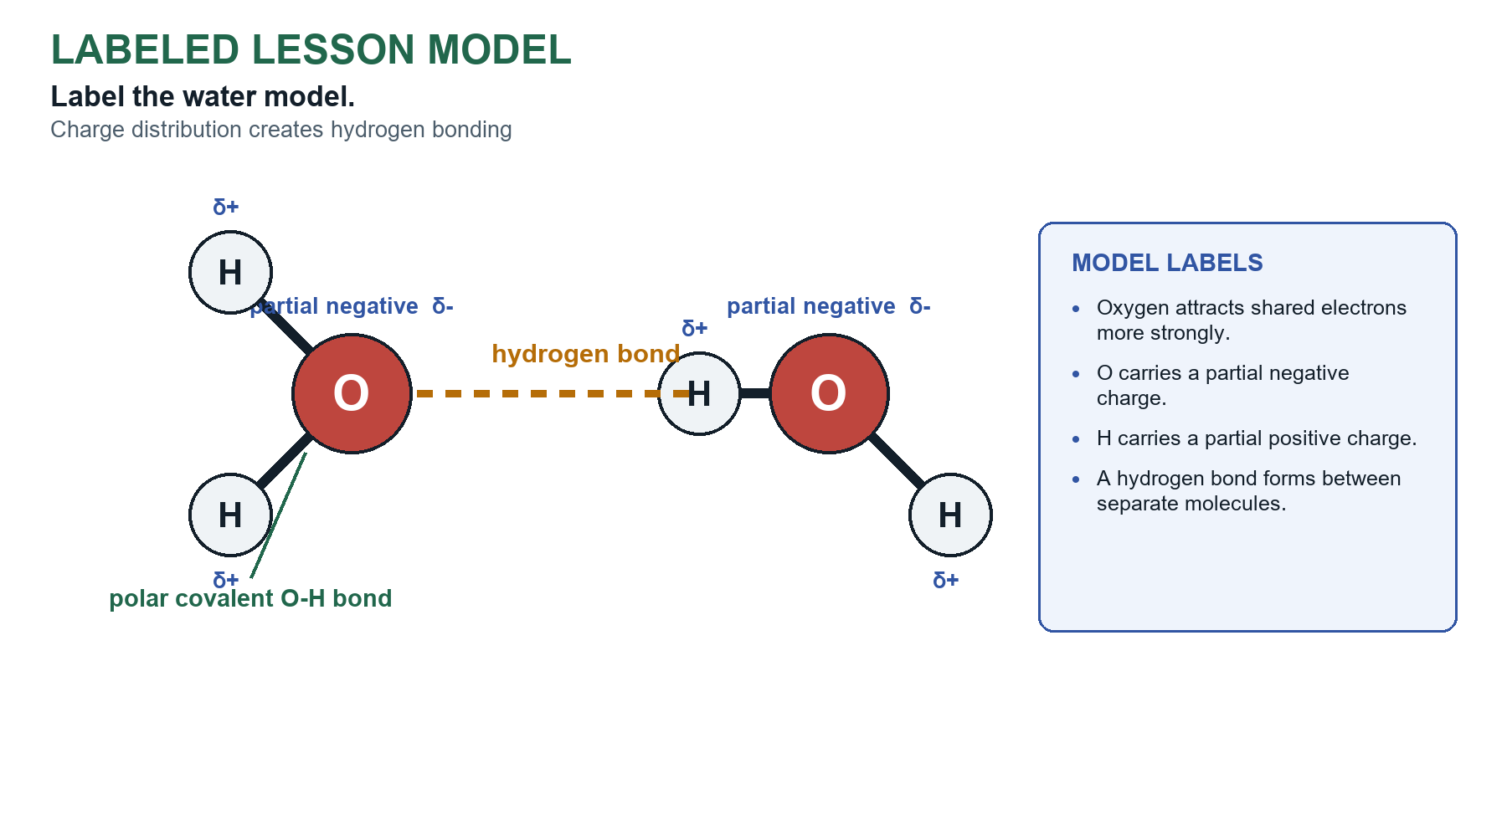
Figure 2 Completed model for Water's Unusual Power

Interactive model conclusion
Rotate a water molecule to form a hydrogen bond Move the orientation slider. A hydrogen bond appears only when a partially positive hydrogen points toward the partially negative oxygen of a neighboring molecule.
Supported relationship A hydrogen bond forms when a partially positive hydrogen is oriented toward a partially negative oxygen on a neighboring molecule.

Waters Molecular Structure
Water has two polar covalent O-H bonds.

Key points
- Cohesion vs. adhesion Cohesion is hydrogen bonding between water molecules. Adhesion is hydrogen bonding between water and a different molecule or polar surface, such as an amino acid or a xylem wall.
- Cohesion Water molecules attract one another through hydrogen bonds.
- Adhesion Water molecules are attracted to other polar or charged surfaces.

Worked example
Question Which claim best explains why a small water strider can remain on the surface of a pond?
- Answer Hydrogen bonding creates cohesion among surface water molecules.
Why it works Hydrogen bonds continually break and reform, but together they create strong cohesion and surface tension.

Cohesion Adhesion and Surface Tension
Hydrogen bonds form between the partially positive hydrogen of one water molecule and the partially negative oxygen of another.

Key points
- Water polarity Oxygen pulls shared electrons more strongly, producing δ− near oxygen and δ+ near hydrogen.
- Hydrogen bond model The δ+ hydrogen of one molecule is attracted to the δ− oxygen of another molecule.

Worked example
Question Select every change that would directly weaken hydrogen bonding among water molecules.
- Answer Replacing water with a nonpolar liquid
- Answer Increasing molecular motion by heating
- Answer Preventing partial charges from forming
Why it works Nonpolarity, greater molecular motion, or loss of partial charges reduces the interactions. Removing solutes does not itself prevent water-water hydrogen bonds.

Water and Temperature Regulation
Cohesion is the pull between water molecules.

Key points
- Specific heat capacity The energy required to raise a substance's temperature. Hydrogen bonding gives water high specific heat capacity and resistance to rapid temperature change.
- Heat of vaporization and cooling The energy required to convert liquid to gas. During evaporation, higher-energy water molecules leave, lowering the remaining liquid's average kinetic energy and temperature.
- Cohesion and adhesion in transpiration Cohesion transmits tension through the column. Adhesion supports water against xylem walls.
- Transpiration chain Hydrogen bonding to cohesion to continuous water column under tension; adhesion supports the column at the wall.
- Temperature chain Hydrogen bonding to high specific heat or heat of vaporization to temperature stability.

Worked example
Question Complete each structure-to-function chain.
- Answer Transpiration through xylem: Cohesion transmits tension; adhesion supports water at polar walls
- Answer Stable aquatic temperature: High specific heat limits rapid temperature change
- Answer Cooling by sweating: High-energy molecules evaporate and remove heat
Why it works Each explanation must connect a molecular property to the observed biological outcome.

Apply Waters Properties
A hydrogen bond is a weak pull between charged parts of nearby molecules.

Key points
- Surface tension Hydrogen bonding among surface molecules produces a cohesive surface.
- Ice floats In ice, hydrogen bonds hold water molecules in a more open pattern, so solid water is less dense than liquid water and floats. Ice that forms on the surface leaves liquid water below, so aquatic organisms can survive in freezing climates.
- Solvent and capillary action Liquid water dissolves many ions and polar molecules, which helps organisms get nutrients from the environment. Water is a very good solvent, but it is not a universal solvent. Adhesion and cohesion also pull water up narrow tubes (capillary action), which plants use to take up soil water.
- Do not overstate Hydrogen bonds are not permanent. Their continuous breaking and reforming produces the bulk property.
- Cause before consequence A strong AP explanation links molecular attraction to physical property to biological outcome.

Worked example
Question Match each observation to the property that most directly explains it.
- Answer Sweating cools a runner: Evaporative cooling
- Answer Water rises through narrow plant vessels: Cohesion and adhesion
- Answer A lake changes temperature more slowly than nearby soil: High specific heat
Why it works Name the property, then connect it to hydrogen bonding or polarity.

AP style transfer
Use the molecular model to explain evidence rather than simply naming a property.

Key points
- One-sentence synthesis Water's polarity enables hydrogen bonding, which produces properties that support transport and temperature stability.
Important Identify names the property.

Worked example
Question Researchers measure cooling after applying equal masses of water or ethanol to identical warm surfaces. Ethanol evaporates faster. Which additional measurement would best support a claim about the energy removed during evaporation?
- Answer Surface temperature over time
Why it works A time-course of surface temperature directly measures the predicted thermal consequence.

What You Should Now Be Able to Explain
- Retrieval Why water molecules form hydrogen bonds
- Retrieval Why hydrogen bonding produces cohesion and surface tension
- Retrieval How high specific heat and high heat of vaporization support thermoregulation
- Retrieval How cohesion and adhesion contribute to transpiration
Key takeaway: Water polarity to hydrogen bonding to emergent properties to transport and temperature stability.

Lesson 02 From Elements to Polymers
  - Topics 1.2-1.3

Central idea
Track how a small set of elements forms biological molecules and how cells assemble or break polymers.

Learning targets
- Identify the major elements used to build biological macromolecules.
- Model dehydration synthesis and hydrolysis.
- Infer how monomer number, type, arrangement, and sequence contribute to molecular diversity.

Science practice focus
Practice 2.A Describe how a molecular model represents monomers, polymers, and reactions.

Labeled lesson model
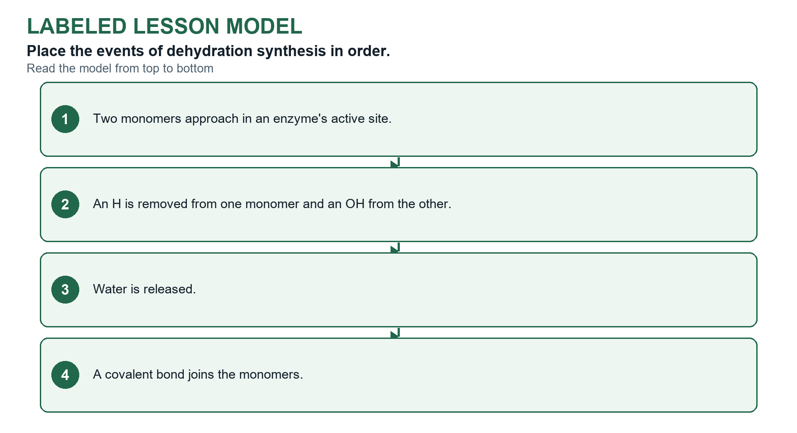
Figure 3 Completed model for From Elements to Polymers

Interactive model conclusion
Build and break a polymer Switch between reactions and track what happens to water and the covalent bond.
Supported relationship Dehydration synthesis removes water to join monomers, whereas hydrolysis uses water to separate them.

Elements of Life
Carbon, hydrogen, and oxygen are the most prevalent elements in biological macromolecules.

Key points
- Most prevalent elements Carbon, hydrogen, and oxygen are most prevalent in biological macromolecules. Carbon forms their carbon skeletons.
- Energy and matter Living systems need a constant input of energy and must exchange matter with the environment. Carbon skeletons (chains, rings, and branches) can store chemical energy and form cell structures.
- Environmental source Organisms obtain atoms from the environment and rearrange them to build biological molecules.
- Elemental roles C, H, and O are prevalent. N supports proteins and nucleic acids; P supports nucleic acids and phospholipids; S occurs in certain amino acids.

Worked example
Question Match the structure to the element especially associated with it.
- Answer Amino group in an amino acid: Nitrogen
- Answer Phosphate in a nucleotide: Phosphorus
- Answer Disulfide bridge in a protein: Sulfur
Why it works The question asks for the element especially diagnostic of each named group.

Monomers and Polymers
Organisms obtain atoms from the environment and rearrange them into biological molecules.

Key points
- Special elemental roles Nitrogen: amino acids and nucleic acids. Phosphorus: nucleic acids and phospholipids. Sulfur: certain amino acids and disulfide bridges in proteins.
- Matter source Organisms obtain atoms from the environment and rearrange them into new molecules.
- Monomer and polymer pairs Specific monomers build specific polymers: monosaccharides build polysaccharides, amino acids build proteins, and nucleotides build nucleic acids. A monomer is a subunit, not a single atom.

Worked example
Question Predict the synthesis most directly limited by each shortage.
- Answer Low environmental nitrogen: Proteins and nucleic acids
- Answer Low environmental phosphorus: Phospholipids and nucleic acids
- Answer Low environmental sulfur: Some proteins
Why it works Connect the missing element to the composition of the molecule rather than memorizing an isolated list.

Dehydration Synthesis
Dehydration synthesis joins small parts and gives off water.

Key points
- Dehydration synthesis H and OH are removed as water while a covalent bond forms between monomers.
- Polymerization Repeated covalent joining of monomers builds a polymer.

Worked example
Question Classify each statement.
- Answer Consumes water while breaking a polymer: Hydrolysis
- Answer Forms a covalent bond between monomers: Dehydration synthesis
- Answer Used during digestion of many polymers: Hydrolysis
Why it works Track both the water molecule and the bond between subunits.

Hydrolysis
Dehydration synthesis joins small parts and gives off water.

Key points
- Hydrolysis Water is added across a covalent bond. H and OH join separate products as the bond breaks.

Worked example
Question Track matter and bond change.
- Answer Hydrolysis: Water reactant; bond broken; more smaller molecules
- Answer Dehydration synthesis: Water product; H and OH removed; bond formed
Why it works A complete model shows the bond direction, water's role, and the products.

Apply Atom Conservation
A monomer is a small molecular part that can join a larger molecule.

Key points
- Sequence and function The identity, number, and order of monomers influence three-dimensional shape and biological function.
- Effect of a sequence change A sequence change may alter folding, binding, catalysis, or stored information; the effect depends on its location.

Worked example
Question Two polymers contain the same number and types of monomers but in different orders. Which conclusion is best supported?
- Answer They may differ in shape or information content.
Why it works Sequence is a source of molecular diversity even when composition is unchanged.

What You Should Now Be Able to Explain
- Retrieval How C, H, O, N, P, and S contribute to biological molecules
- Retrieval How dehydration synthesis conserves atoms while forming a covalent bond
- Retrieval How hydrolysis uses water to break a covalent bond
- Retrieval Why monomer sequence can change polymer function
Key takeaway: Organisms rearrange environmental atoms; dehydration builds and hydrolysis breaks biological molecules.

Lesson 03 Carbohydrates and Lipids
  - Topics 1.4-1.5

Central idea
Compare molecules that provide quick energy or structure with hydrophobic molecules that store energy and form membranes.

Learning targets
- Connect monosaccharide structure and glycosidic bonds to carbohydrate functions.
- Compare triglycerides, phospholipids, and steroids.
- Predict how saturation and amphipathic structure affect molecular behavior.

Science practice focus
Practice 1.A and 6.E Describe structure-function relationships and predict how a structural change affects function.

Labeled lesson model
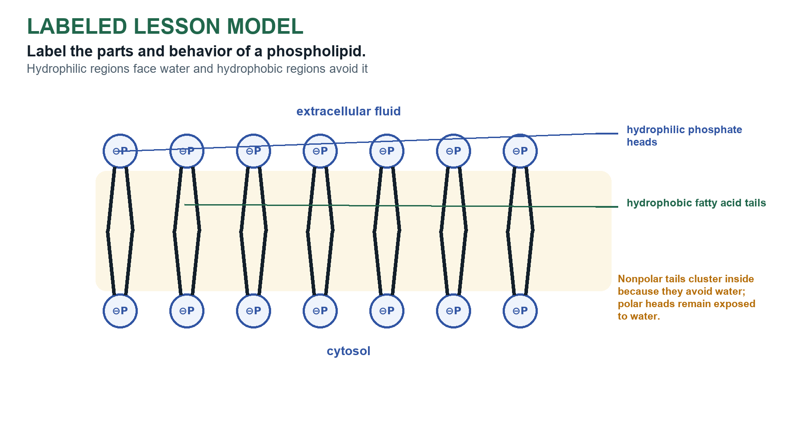
Figure 4 Completed model for Carbohydrates & Lipids

Interactive model conclusion
Structure changes packing and function Compare lipid tails and observe how their shape affects packing.
Supported relationship Cis double bonds bend unsaturated fatty-acid tails, reduce tight packing, and generally increase membrane fluidity.

Carbohydrate Structure
A monomer is a small molecular part that can join a larger molecule.

Key points
- Carbohydrate organization Monosaccharides join by covalent bonds (called glycosidic bonds) into linear or branched polysaccharides.

Worked example
Question Match each carbohydrate to its most direct role.
- Answer Glycogen: Animal glucose storage
- Answer Starch: Plant glucose storage
- Answer Cellulose: Plant cell-wall structure
Why it works Similar glucose-based polymers can differ in linkage and biological role.

Carbohydrate Functions
A monomer is a small molecular part that can join a larger molecule.

Key points
- Carbohydrate functions Glucose provides energy for cells; starch stores energy in plants; glycogen stores energy in animals; cellulose supports plant cell walls.
- Direction of subunits matters Glucose can differ in the direction of one OH group. Joined one way it makes starch, which stores energy in plants. Joined the other way it makes cellulose, which supports plant cell walls. Some starch is linear, so judge by the picture.
- Starch, glycogen, and cellulose Starch (plants) and glycogen (animals) are similar branched polymers that store energy. Cellulose is linear, and hydrogen bonds between side-by-side strands cluster them into strong fibers.
Important Describe the shape in a picture, linear or branched, and then relate it to the function.

Worked example
Question Connect polymer organization to the model or role.
- Answer A chain with side branches: Branched polysaccharide
- Answer A single unbranched sequence of connected sugars: Linear polysaccharide
- Answer Starch or glycogen: Energy storage
Why it works Classify the organization or broad role without memorizing excluded chemical structures.

Lipid Structure and Properties
A monomer is a small molecular part that can join a larger molecule.

Key points
- General lipid property Lipids are typically nonpolar and hydrophobic, and are not true polymers because they do not all have repeating monomer subunits.
- Saturation comparison Saturated tails have only C-C single bonds. Unsaturated tails have double-bond kinks.
- Saturated No carbon-carbon double bonds in fatty-acid chains; chains pack closely.
- Unsaturated One or more cis double bonds create bends that reduce close packing.

Worked example
Question A membrane contains a larger proportion of unsaturated phospholipid tails. At the same temperature, what is the most likely effect?
- Answer Looser packing and greater fluidity
Why it works Cis double-bond bends hinder close packing, generally increasing fluidity.

Saturated and Unsaturated Fatty Acids
Saturated fatty acids contain only carbon-carbon single bonds.

Key points
- Unsaturation and state More double bonds to more kinks to less packing to more liquid at room temperature.
- Hydrogenation Fewer double bonds to more saturation and packing to greater solidity.

Worked example
Question Match each lipid change or type to its consequence.
- Answer More cis carbon-carbon double bonds: More kinks and greater liquidity
- Answer Hydrogenation: More saturation and greater solidity
- Answer Stored fat in a mammal: Energy storage and possible insulation
Why it works Use the carbon-bond pattern to predict packing and state, then distinguish the functions of lipid types.

Types and Functions of Lipids
Fats can store energy.

Key points
- Lipid functions Triglycerides store energy and insulate. Steroids include hormones and cholesterol. Cholesterol contributes to stability and fluidity in animal membranes.
- Amphipathic phospholipids A phospholipid has a polar hydrophilic head and nonpolar hydrophobic tails. In water, heads face water and tails point inward to form a bilayer.

Worked example
Question Match each lipid structure to its broad biological role.
- Answer Triglyceride (fat): Energy storage
- Answer Steroid with four fused carbon rings: Membrane component or signaling molecule
- Answer Cholesterol: Steroid in animal-cell membranes
Why it works Broad lipid structure supports broad biological function: fats store energy, while steroids can function in membranes or signaling.

Phospholipids and Cell Membranes
Use molecular evidence to classify a molecule: rings, long hydrocarbon regions, many hydroxyl groups, or a charged phosphate.

What You Should Now Be Able to Explain
- Retrieval How linear and branched polysaccharides support different functions
- Retrieval Why lipids are generally hydrophobic
- Retrieval How C=C double bonds change fatty-acid packing and fluidity
- Retrieval Why phospholipids form bilayers in water
Key takeaway: Molecular assembly changes shape, packing, interactions with water, and biological function.

Lesson 04A Nucleic Acids
  - Topic 1.6

Central idea
Read nucleotide models to connect sequence, directionality, pairing, and DNA/RNA structure to information storage.

Learning targets
- Identify the three parts of a nucleotide and explain how sequence stores information.
- Compare DNA and RNA using sugar, base, and typical strand organization.
- Interpret 5′ and 3′ ends, antiparallel orientation, and complementary base pairing.

Labeled lesson model
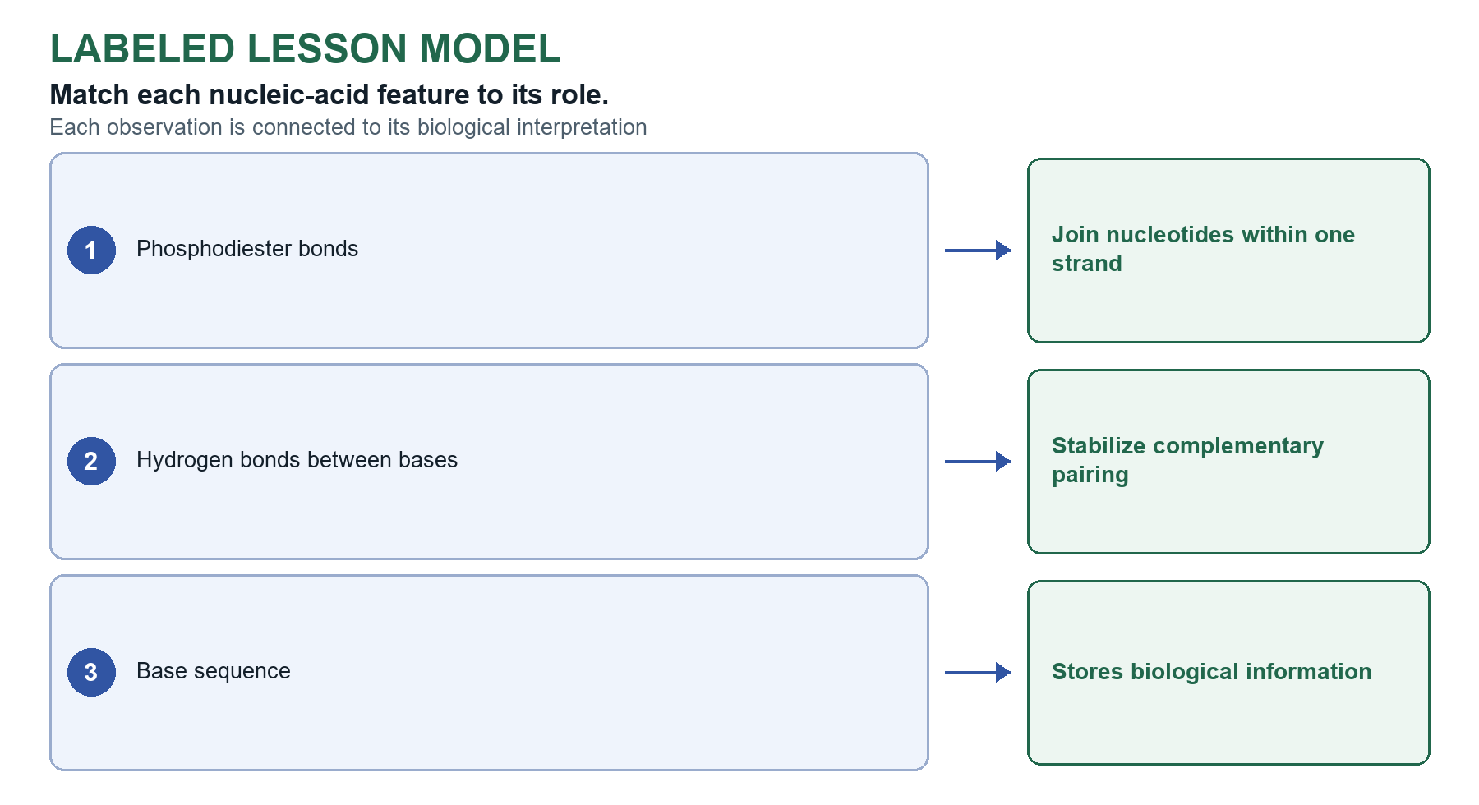
Figure 5 Completed model for Nucleic Acids

Nucleotide Structure
Nucleic acids store and transmit genetic information.

Key points
- Nucleotide Five-carbon sugar + phosphate + nitrogenous base. Nucleotide sequence stores biological information.

Worked example
Question Match each nucleic-acid feature to its role.
- Answer Phosphodiester bonds: Join nucleotides within one strand
- Answer Hydrogen bonds between bases: Stabilize complementary pairing
- Answer Base sequence: Stores biological information
Why it works Separate the covalent backbone from hydrogen bonding between bases.

DNA and RNA
DNA contains deoxyribose and thymine and is usually double stranded.

Key points
- DNA vs. RNA DNA: deoxyribose, T, usually double stranded, and stores genetic information. RNA: ribose, U, usually single stranded, and participates in using genetic information.

Worked example
Question Interpret the structural clue.
- Answer Free terminal phosphate: 5′ end
- Answer Free terminal hydroxyl: 3′ end
- Answer Ribose, uracil, usually one strand: RNA
Why it works Directionality, sugar, base, and strand organization are independent clues.

Nucleic Acid Structure and Directionality
Covalent phosphodiester bonds join nucleotides in a sugar-phosphate backbone.

Key points
- Sugar-phosphate backbone Covalent bonds (phosphodiester bonds) join the phosphate of one nucleotide to the sugar of the next, forming the sugar-phosphate backbone of each strand.
- Directionality 5′ end has phosphate. 3′ end has a free hydroxyl. New nucleotides are added to the 3′ end.

Worked example
Question Identify the directionality clues in a nucleic-acid model.
- Answer Free terminal phosphate: 5′ end
- Answer Free terminal hydroxyl: 3′ end
- Answer New nucleotide joins a growing strand: At the 3′ end
Why it works A phosphate identifies the 5′ end, a free hydroxyl identifies the 3′ end, and synthesis extends the growing 3′ end.

Complementary Base Pairing
DNA is an antiparallel double helix.

Key points
- Antiparallel pairing DNA strands run oppositely. A-T and C-G pair by hydrogen bonds; RNA can use A-U.
- Hydrogen bonds and stability A-T pairs have two hydrogen bonds and G-C pairs have three. A DNA segment with more G-C pairs has more hydrogen bonds, is more stable, and needs more heat to separate.
Important When a prediction names two things, address both.

Worked example
Question One DNA strand runs 5′-A C G T-3′. Which complementary antiparallel strand is correct?
- Answer 3′-T G C A-5′
Why it works Complementary bases pair A-T and C-G, and the paired strand runs in the opposite direction.

What You Should Now Be Able to Explain
- Retrieval The three parts of a nucleotide
- Retrieval How DNA and RNA differ
- Retrieval How 5′ and 3′ ends establish directionality
- Retrieval Why complementary pairing and antiparallel orientation matter in DNA
Key takeaway: Nucleotide sequence stores genetic information; complementary base pairing and antiparallel strands support DNA structure and function.

Lesson 04B Proteins
  - Topic 1.7

Central idea
Trace how amino-acid sequence and R-group interactions build protein shape and biological function.

Learning targets
- Identify amino-acid parts and peptide bonds.
- Describe primary, secondary, tertiary, and quaternary protein structure.
- Predict how sequence or environmental changes may affect protein function.

Labeled lesson model
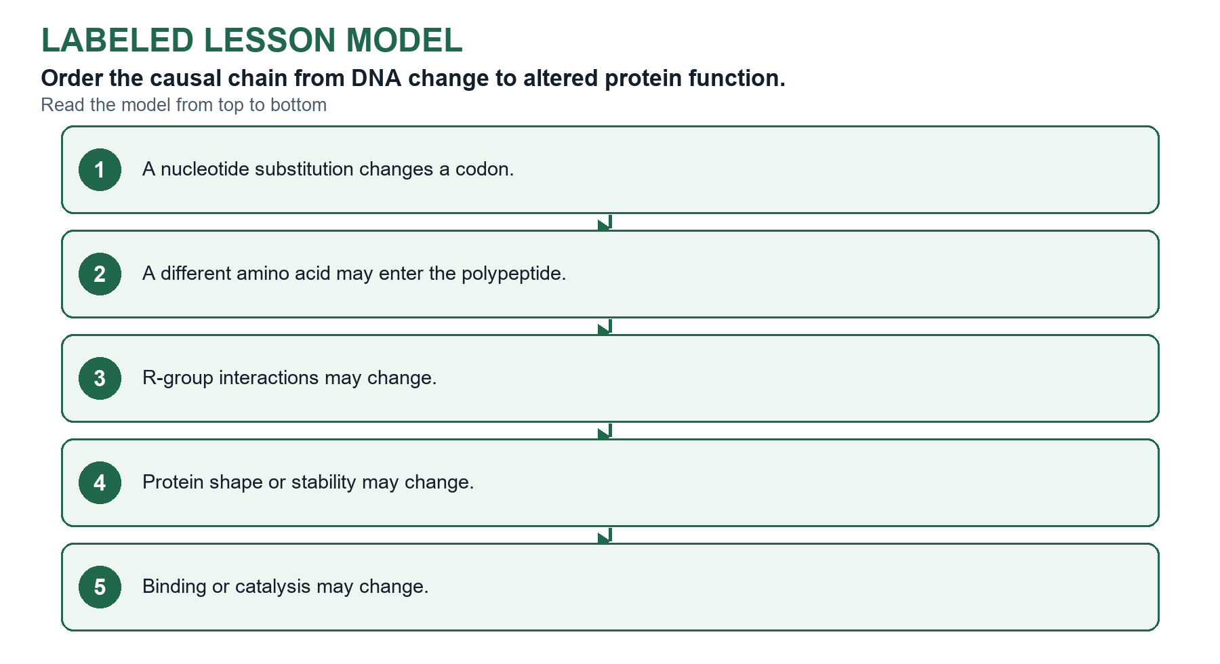
Figure 6 Completed model for Proteins

Amino Acid Structure
Amino acids are the monomers of proteins.

Key points
- Amino acid Central carbon bonded to H, amino group, carboxyl group, and variable R group. R groups may be nonpolar, polar, or charged.

Worked example
Question Identify the protein-building feature.
- Answer Common amino-acid components: Central carbon, H, amine, carboxyl, R group
- Answer Peptide bond forms between: Carboxyl group and amine group
- Answer R-group categories: Nonpolar, polar, or ionic
Why it works Recognize the common plan and chemical categories without memorizing excluded structures of specific amino acids.

Peptide Bonds
A peptide bond is a covalent bond between the carboxyl group of one amino acid and the amino group of the next.

Key points
- Peptide bond Covalent bond between the carboxyl group of one amino acid and the amino group of the next. A polypeptide is a chain of amino acids joined by peptide bonds.
- Amino and carboxyl ends An amino acid has an amino terminus (amine group) and a carboxyl terminus. A growing polypeptide gains new amino acids at its carboxyl end.
- Primary structure The amino-acid sequence.
- Higher-order structure Local folding, overall three-dimensional shape, and sometimes multiple subunits.

Worked example
Question Identify the peptide-bond relationship.
- Answer Bond that joins amino acids in a polypeptide: Peptide bond
- Answer Groups that form a peptide bond: Carboxyl group and amino group
- Answer A chain of amino acids: Polypeptide
Why it works Peptide bonds are covalent links between the carboxyl group of one amino acid and the amino group of the next.

Four Levels of Protein Structure
A hydrogen bond is a weak pull between charged parts of nearby molecules.

Key points
- Protein levels Primary = sequence; secondary = alpha helices and beta sheets stabilized by backbone hydrogen bonds; tertiary = one chain's 3-D shape; quaternary = two or more subunits.

Worked example
Question Match the evidence to the protein-structure level.
- Answer Amino-acid sequence: Primary
- Answer Alpha-helix stabilized by backbone hydrogen bonds: Secondary
- Answer Hydrophobic, ionic, hydrogen-bond, and disulfide interactions shape one chain: Tertiary
Why it works Identify both the scale of organization and the interactions present.

R Group Interactions and Folding
Nonpolar R groups often cluster away from water in soluble proteins.

Key points
- R-group interactions Hydrophobic interactions, hydrogen bonds, ionic interactions, and cysteine disulfide bridges support folding.
- Folding in water In water, nonpolar (hydrophobic) R groups fold toward the core and polar R groups face the water. Many proteins work at the tertiary level, and hemoglobin needs quaternary structure.

Worked example
Question Match each R-group property to a likely location in a soluble protein.
- Answer Nonpolar side chain: Often buried away from water
- Answer Charged side chain: Often exposed to water or paired with opposite charge
- Answer Cysteine side chains: Can form disulfide bonds
Why it works These are tendencies, not absolute rules; the local molecular environment matters.

Protein Structure and Function
Amino acid sequence influences R-group interactions, folding, and three-dimensional shape.

Key points
- Sequence-to-function chain Sequence to R-group interactions to folding/shape to function. A substitution's effect depends on location and chemical consequences.
Important When a question asks for two predictions, such as fit with a signal molecule and function, address both.

Denaturation
Denaturation is a change in protein three-dimensional shape that can reduce or eliminate function.

Key points
- Denaturation Temperature, pH, or solutes can disrupt shape and function without necessarily breaking peptide bonds.

Worked example
Question Select every result that could follow an amino-acid substitution.
- Answer No measurable change in function
- Answer Altered folding
- Answer Changed ligand binding
Why it works Effects range from neutral to major depending on location and R-group chemistry.

What You Should Now Be Able to Explain
- Retrieval The common structure of an amino acid
- Retrieval How peptide bonds create a polypeptide
- Retrieval How the four levels of protein structure differ
- Retrieval Why sequence or environmental changes may affect protein function
Key takeaway: Amino acid sequence to R-group interactions to folding and three-dimensional shape to biological function.

Lesson 05 Macromolecule Evidence Lab
  - Topics 1.1-1.7 synthesis

Central idea
Identify unknown samples by choosing chemical tests, recording evidence, and ruling out alternatives.

Learning targets
- Select tests that detect reducing sugars, starch, protein, or lipids.
- Interpret positive and negative controls before unknown results.
- Defend a sample identification with multiple lines of evidence.

Science practice focus
Practice 6.B and 6.C Support a claim with evidence and connect the evidence to biological reasoning.

Labeled lesson model
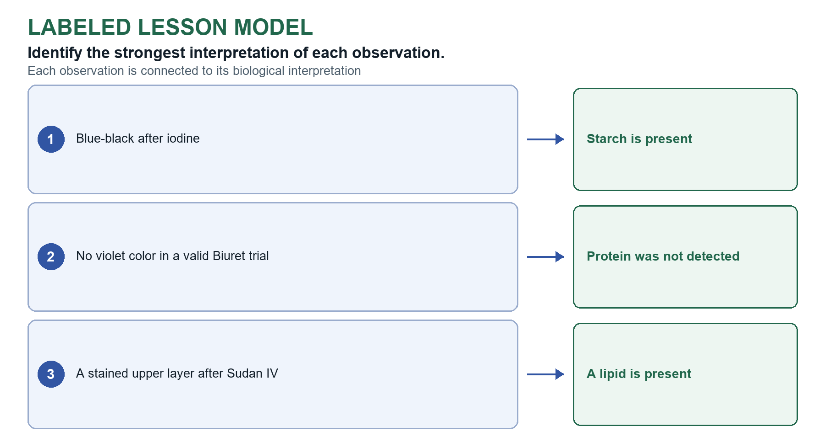
Figure 7 Completed model for Macromolecule Evidence Lab

Interactive model conclusion
Use controls to interpret indicator tests Compare an unknown result with known positive and negative results.
Supported relationship Positive and negative controls establish the signals needed to interpret an unknown sample.

Experimental Controls
Four unlabeled samples contain glucose solution, starch solution, egg-white protein, or vegetable oil.

Key points
- Positive and negative controls A positive control contains the target and confirms detection. A negative control lacks the target and establishes the expected negative result.
- Benedict's + heat Positive reducing-sugar result: blue changes toward green, yellow, orange, or brick red.
- Iodine Positive starch result: amber changes to blue-black.
- Biuret Positive protein result: blue changes to violet.
- Sudan IV Positive lipid result: stained oil layer separates.

Worked example
Question Why should known positive and negative controls be tested?
- Answer To show that the test can distinguish presence from absence under the trial conditions
Why it works Controls establish that the procedure and reagents can produce interpretable positive and negative outcomes.

Chemical Tests for Macromolecules
Choose a sample and a chemical test.

Key points
- Benedict's test After heating, a green-to-brick-red change detects reducing sugar.
- Iodine test A blue-black change detects starch.
- Biuret test A violet change detects peptide bonds/protein.
- Sudan IV test A separated stained layer supports the presence of lipid.

Using Evidence to Identify an Unknown
A strong conclusion names the sample and cites a diagnostic positive result.

Key points
- Evidence rule Use a diagnostic positive and relevant negative result. Claim only what the test detects.
- CER frame Identify the unknown, cite results, and explain how the results support or rule out alternatives.

Worked example
Question Connect each unknown to broader molecular evidence.
- Answer Starch-positive sample: A polysaccharide built from covalently joined monosaccharides
- Answer Biuret-positive sample: Contains peptide bonds associated with protein
- Answer Sudan-positive sample: Contains hydrophobic lipid material
Why it works Use the chemical test and Unit 1 structure-function knowledge together.

What You Should Now Be Able to Explain
- Retrieval Why positive and negative controls are needed
- Retrieval What each indicator test detects
- Retrieval How a negative result can rule out an alternative
- Retrieval How to write a claim-evidence-reasoning identification
Key takeaway: A defensible identification combines valid controls, diagnostic results, and a claim limited to what the tests show.

Optional 0A Scientific Method Design and Controls
  - AP Biology Science Practices

Central idea
Write a testable hypothesis, define the variables that make a comparison fair, and choose controls that make a result interpretable.

Learning targets
- Write a testable hypothesis and a directional prediction.
- Identify independent, dependent, and controlled variables.
- Choose positive, negative, and same-procedure controls and say what each rules out.

Science practice focus
Practice 3.C and 4.B Identify variables and appropriate controls, then describe patterns and relationships in data.

Labeled lesson model
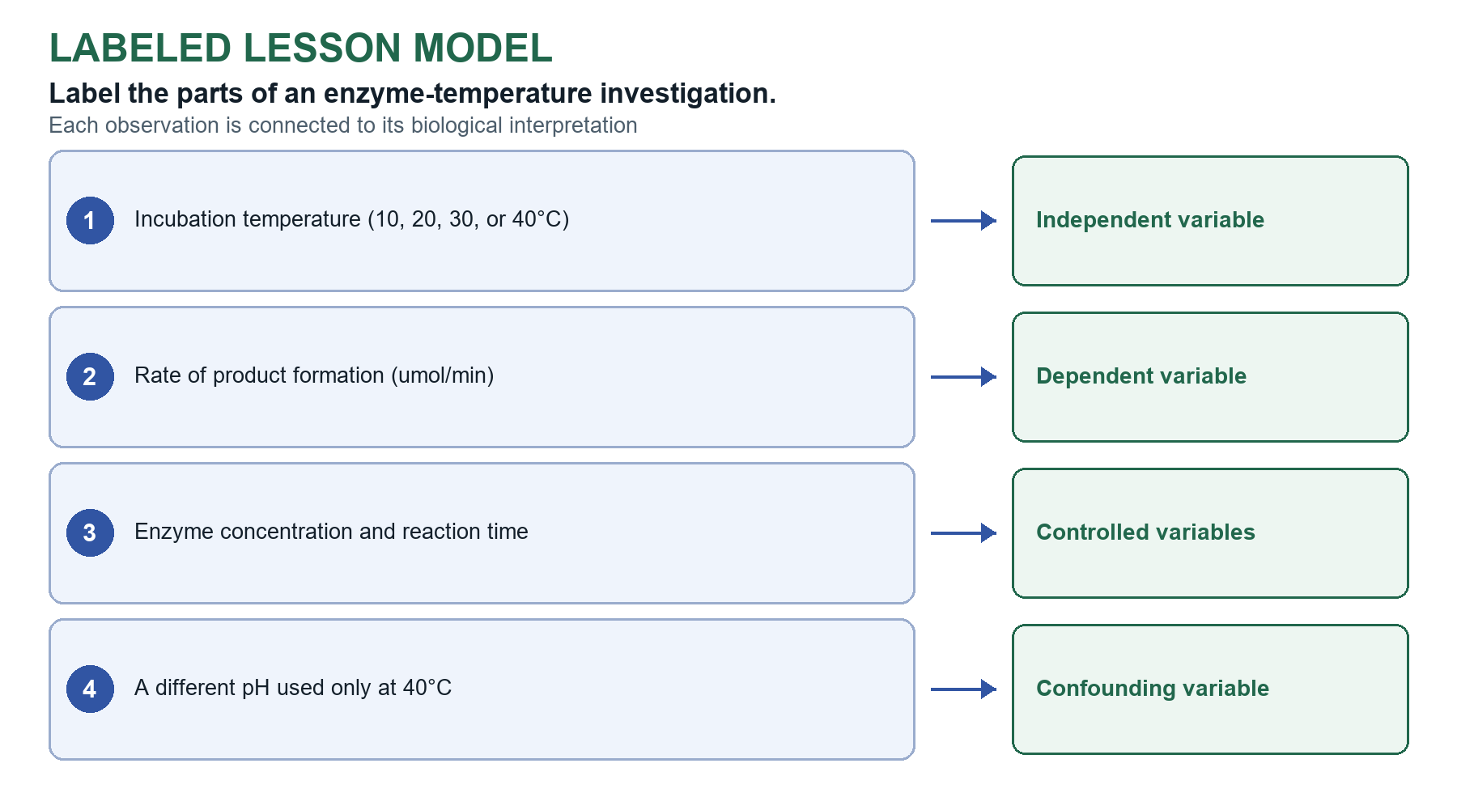
Figure 8 Completed model for Scientific Method: Design & Controls

Interactive model conclusion
Build a fair comparison Change the setup, then decide which comparison isolates the active treatment.
Supported relationship A fair comparison changes the independent variable while keeping other plausible causes constant.

Scientific Investigations
Scientific investigations often begin with an observation and a focused question.

Key points
- Observation Information collected about a phenomenon.
- Hypothesis A tentative, testable, and falsifiable explanation-not a question or a guaranteed fact.
- Prediction The measurable result expected if the hypothesis is supported, often written as an if-then statement.
- Null hypothesis The treatment or variables have no effect or association beyond chance.
- Evidence rule Evidence may support or fail to support a hypothesis; one experiment does not prove it true.
- Hypothesis A mechanistic explanation that can be tested and could be contradicted by evidence.
- Prediction A measurable expected outcome, often written as an if-then statement.
Important Do not say that one test proves a hypothesis or that an observed association proves causation.

Worked example
Question Classify each statement about light and seedling growth.
- Answer Blue light increases growth because it activates a receptor that promotes cell elongation.: Hypothesis
- Answer If the explanation is supported, seedlings under blue light will have a greater mean height than seedlings in darkness.: Prediction
- Answer Seedlings near the window appeared taller.: Observation
Why it works An observation motivates a question, a hypothesis explains, a prediction forecasts a measurable result, and the null proposes no effect or association.

Variables define the comparison
The dependent variable is the result that the test measures.

Key points
- Independent and dependent variables The independent variable is the factor the investigator deliberately changes. The dependent variable is the measured response.
- Controlled variables Conditions intentionally kept the same across groups so the comparison isolates the independent variable.
- Experimental and control groups The experimental group receives the treatment; the control group provides the comparison.
- Confounding variable A factor that changes along with the independent variable and creates another possible explanation for the result.
Important Do not say one test proves a hypothesis or turns a link into a cause.

Worked example
Question Label the parts of an enzyme-temperature investigation.
- Answer Incubation temperature (10, 20, 30, or 40°C): Independent variable
- Answer Rate of product formation (µmol/min): Dependent variable
- Answer Enzyme concentration and reaction time: Controlled variables
Why it works A fair test changes the independent variable while measuring the dependent variable and holding other plausible causes constant.

Controls make results interpretable
A negative control should show no treatment effect and sets the baseline.

Key points
- Negative control An expected baseline or negative result that reveals background or contamination. A same-procedure control receives the solvent or carrier without the active treatment.
- Positive control A condition known to produce the response, showing that the test system itself is working.
- Negative control Expected negative or baseline result: What happens without the active treatment?
- Positive control Expected known response: Can this setup detect the response at all?
- Same procedure without treatment Receives the same carrier or procedure without the active substance.
Important Do not claim a treatment effect if the controls make the result hard to interpret.

Worked example
Question Choose the most informative control for each investigation.
- Answer Testing whether an antibiotic prevents bacterial growth: Bacteria with no antibiotic (negative control)
- Answer Checking whether a glucose test strip can detect glucose: Known glucose solution (positive control)
- Answer A drug is dissolved in ethanol before being added to cells: Cells given the same ethanol without drug
Why it works Negative controls establish baseline, positive controls verify detection, and a same-procedure control separates the active treatment from its carrier.

What You Should Now Be Able to Explain
- Retrieval How a hypothesis differs from a prediction
- Retrieval How independent and dependent variables define a test
- Retrieval Why positive, negative, and same-procedure controls are useful
Key takeaway: A fair test changes one planned factor, measures a response, and uses controls to make the comparison interpretable.

Optional 0B Scientific Method Data and Conclusions
  - AP Biology Science Practices

Central idea
Design for reliability, represent data with its uncertainty, and argue from evidence without overclaiming.

Learning targets
- Use replication, sample size, and randomization to support a claim.
- Choose a data display and quantify uncertainty.
- Write a conclusion that distinguishes association from causation.

Labeled lesson model
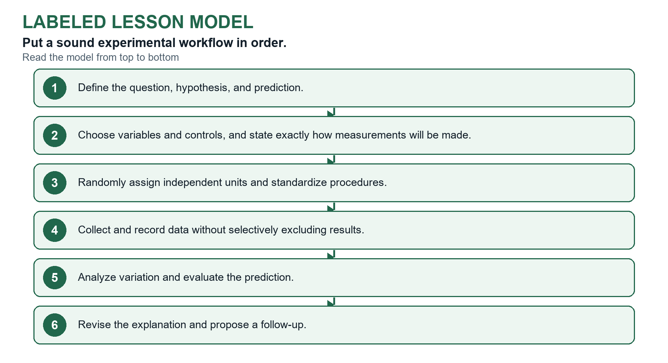
Figure 9 Completed model for Scientific Method: Data & Conclusions

Design for reliability and reduced bias
Biological replicates are independent organisms, cultures, or experimental units exposed to the same condition.

Key points
- Replicates A biological replicate is an independent organism, culture, or experimental unit. A technical replicate is a repeated measurement of the same unit.
- Sample size More independent samples better represent biological variation and improve the estimate.
- Random assignment and bias Random assignment reduces systematic differences among groups; standardized methods and blinding reduce measurement and observer bias.
Important Do not say one test proves a hypothesis or turns a link into a cause.

Worked example
Question Evaluate each design choice.
- Answer Twenty independently grown plants per fertilizer group: Biological replication
- Answer Reading the same sample three times on one spectrophotometer: Technical replication
- Answer Assigning plants to treatments with a random-number generator: Reduces allocation bias
Why it works Independent units support generalization; repeated measurements improve measurement precision but do not increase the number of independent organisms.

Represent data and quantify uncertainty
Give tables clear titles, labeled columns, units, and raw observations.

Key points
- Graph axes Place the independent variable on the x-axis and the dependent variable on the y-axis.
- Graph choice Use bars for groups, lines for ordered change, and scatterplots for two measured quantities.
- Rate Change in the measured quantity divided by change in time.
- Mean The arithmetic average of a set of values.
- Standard deviation Describes the spread of individual values around the mean.
- Standard error and confidence intervals Standard error estimates uncertainty in a sample mean. A confidence interval describes uncertainty in an estimated population parameter.
- Error bars Represent a specified measure of variation or uncertainty; identify their meaning before interpreting them.

Worked example
Question Choose the most appropriate display or calculation.
- Answer Mean enzyme rate at four temperatures: Line graph
- Answer Relationship between body mass and oxygen consumption: Scatterplot
- Answer Change from 12 cm to 15 cm: 25% increase
Why it works Percent change = (new − original) ÷ original × 100; rate = change in amount ÷ change in time.

Argue from evidence without overclaiming
A strong conclusion uses claim-evidence-reasoning.

Key points
- Claim-evidence-reasoning State the conclusion, cite specific evidence, and explain the biological reasoning that links them.
- Causation and limitations A controlled test can support causation; an observational association cannot. Name a design limit or alternative explanation and propose a focused next test.

Worked example
Question A survey finds that students who sleep more have higher test scores. Which conclusion is justified?
- Answer Sleep duration and score are associated, but confounding variables prevent a causal conclusion.
Why it works An observational association may motivate a hypothesis, but it does not isolate sleep from other differences among students.

What You Should Now Be Able to Explain
- Retrieval Why biological replicates differ from repeated measurements
- Retrieval How graph choice and error bars affect interpretation
- Retrieval Why association does not by itself establish causation
- Retrieval How claim, evidence, and reasoning work together
Key takeaway: Strong conclusions match the design and evidence without claiming more than the data support.

